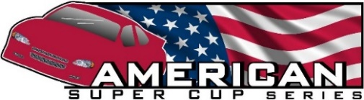

American Super Cups Racing Series/Grundy County Speedway Super Cups
2024 Schedule

The Premier Super Cup Racing Series - Est. 1999 - 25 Seasons of Super Cup Racing!

American Super Cups Racing Series is pleased to announce our race schedule. We offer the best Super Cup Racing level of competition for beginners to veterans of racing. This schedule allows for racing on a consistent basis. You can challenge yourself and race with the travel series at tracks in Wisconsin and Illinois, race locally at Grundy County Speedway or do both series. Stay tuned and check back as the season continues to fill up with show dates and specific track times.

Visit our website at www.americansupercups.com email americansupercups@yahoo.com Call/Text 312-350-5566

December 7-9, 2023 PRI Show – Indianapolis $1,800.00/spot

February 23-25 World of Wheels–Milwaukee-Wisconsin State Fairgrounds $50.00/spot 10x10
# at show

March 8-10 World of Wheels–Chicago-Rosemont Convention Center $50.00/spot 10x10
#16 & 8 at Show

American Super Cups Travel Series Racing - 13 Races
Grundy County Speedway Super Cup Racing - 10 Races

April 6 (Sat) Practice? Information to follow
April 13 (Sat) Practice - Grundy County Speedway 12;00-5:00
April 19 (Fri) Practice - Grundy County Speedway 5:00-9:00
April 20 (Sat) 1. Grundy County Speedway – Spring Classic Opener
April 27 (Sat) Off

May 4 (Sat) Off
May 10 (Fri) 1F. Grundy County Speedway
May 11 (Sat) 2. Dells Raceway Park
May 18 (Sat) Off
May 24 (Fri) 2F. Grundy County Speedway
May 27 (Mon) 3. Golden Sands - Memorial Day – Trickle 99

June 1 (Sat) Off
June 7 (Fri) 3F. Grundy County Speedway
June 16 (Sun) 4. Slinger Speedway – Evening Race
June 21 (Fri) 4F. Grundy County Speedway
June 22 (Sat) 5. Dells Raceway Park
June 28 (Fri) Back 2 Back 6. Tomah Speedway-4th of July-Thunder in the Valley-Big 8 Firecracker
June 29 (Sat)Back 2 Back 7. La Crosse Speedway – Full night of Racing

July 5 (Fri) 5F. Grundy County Speedway
July 12 (Fri) 6F. Grundy County Speedway
July 14 (Sun) 8. Slinger Speedway-evening race - Small Car Nationals
July 19 (Fri) 7F. Grundy County Speedway
July 20 (Sat) 9/10. Dells Raceway Park – Monster Truck/Double Race Afternoon/Evening
July 27(Sun) Off

August 3 (Sat) 8F. Grundy County Speedway
August 10 (Sat) Off
August 17 (Sat) 11. Grundy County Speedway – Back to school special
August 24 (Sat) Off
August 30 (Fri) 9F. Grundy County Speedway

September 2 (Mon) 12. Golden Sands-Labor Day-Tundra Series
September 8 (Sun) 13. Slinger Speedway-day race Championship Sunday
September 21 (Sat) 10F. Grundy County Speedway – Grundy County Super Cup Championship

December - TBA 2024 – 25th Annual American Super Cup Racing Series Championship Banquet

If there is a rain out - No races will be rescheduled!

Have more of need for speed? - Any track may be rented based on availability Release - 1/29/2024

Central States Region Super Cup Racing
American Super Cups Racing Series
And
Grundy County Speedway

Choose to race in the ASCS travel series, Friday nights at Grundy County Speedway or both series!!

American Super Cups Travel Series Racing - 13 Races – 6 Tracks

Practice? Additional tracks - Information to follow
April 13 (Sat) Practice - Grundy County Speedway 12;00-5:00
April 19 (Fri) Practice - Grundy County Speedway 5:00-9:00

April 20 (Sat) 1. Grundy County Speedway – Combo race w/GSC - Spring Classic Opener

May 11 (Sat) 2. Dells Raceway Park
May 27 (Mon) 3. Golden Sands - Memorial Day – Trickle 99

June 16 (Sun) 4. Slinger Speedway – Evening Race
June 22 (Sat) 5. Dells Raceway Park
June 28 (Fri) Back 2 Back 6. Tomah Speedway-4th of July-Thunder in the Valley-Big 8 Firecracker
June 29 (Sat)Back 2 Back 7. La Crosse Speedway – Full night of Racing

July 14 (Sun) 8. Slinger Speedway-evening race - Small Car Nationals
July 20 (Sat) 9/10. Dells Raceway Park – Monster Truck/Double Race Afternoon/Evening

August 17 (Sat) 11. Grundy County Speedway – Combo race w/GSC - Back to school special

September 2 (Mon) 12. Golden Sands-Labor Day-Tundra Series
September 8 (Sun) 13. Slinger Speedway-day race Championship Sunday

Grundy County Speedway Super Cup Racing - 10 Races

April 13 (Sat) Practice - Grundy County Speedway 12;00-5:00
April 19 (Fri) Practice - Grundy County Speedway 5:00-9:00

April 20 (Sat) 1. Grundy County Speedway – Combo race w/ASCS - Spring Classic Opener

May 10 (Fri) 1F. Grundy County Speedway
May 24 (Fri) 2F. Grundy County Speedway

June 7 (Fri) 3F. Grundy County Speedway
June 21 (Fri) 4F. Grundy County Speedway

July 5 (Fri) 5F. Grundy County Speedway
July 12 (Fri) 6F. Grundy County Speedway
July 19 (Fri) 7F. Grundy County Speedway

August 3 (Sat) 8F. Grundy County Speedway
August 17 (Sat) 11. Grundy County Speedway – Combo race w/ASCS - Back to school special
August 30 (Fri) 9F. Grundy County Speedway

September 21 (Sat) 10F. Grundy County Speedway – Grundy County Super Cup Championship

Registration is $150.00 for each series – If you want to race both - the 2nd series cost $75.00 – Cost goes up 3/1/24.
Registration for either series entitles you to series benefits, nightly payout and year end prize money if you attend 75% of the races.
Both series are subject to American Super Cups Series rules and regulations. Only ASCS sealed motors are allowed.

You can also race individual nights for $75.00/night – You are not entitled to nightly payout or Year-end prize money.

2023 American Super Cups Racing Series Schedule 2/8/23

February 24-26 World of Wheels–Milwaukee-Wisconsin State Fairgrounds $50.00/spot 10x10
# at show

March 3-5 World of Wheels–Chicago-Rosemont Convention Center $50.00/spot 10x10
#41 & 16 at Show

April 1 (Sat) Practice? Information to follow
April 8 (Sat) Practice? Information to follow
April 15 (Sat) Practice? Information to follow
April 23 (Sun) 1. Slinger-Day race-24th Annual Season Opener
April 29 (Sat) Practice? Information to follow

May 6 (Sat) Open
May 13 (Sat) 2. Dells Raceway Park-Full night of Racing-Pro Lates, Mods, Bandits & Sixers
May 20 (Sat) 3. Rockford Speedway
May 27 (Sat) Open
May 29 (Mon) 4. Golden Sands - Memorial Day – Trickle 99
,
June 3 (Sat) Open
June 10 (Sat) Open
June 17 (Sat) Open
June 24 (Sat) 5. LaCrosse Speedway – Full night of Racing
June 30 (Fri) 6. Tomah Speedway-4th of July-Thunder in the Valley-Big 8 Firecracker

July 1 (Sat) Open
July 8 (Sat) Open
July 15 (Sat) 7. Dells Raceway Park-Full Night of Racing-Super Lates, 602’s, Sportsman, Legends
July 16 (Sun) 8. Slinger Speedway-evening race - Small Car Nationals
July 22 (Sat) Open
July 29 (Sat) 9. Rockford Speedway

August 5 (Sat) Open
August 12 (Sat) Open
August 19 (Sat) Open
August 26 (Sat) 10. Rockford Speedway

September 4 (Mon) 11. Golden Sands-Labor Day-Tundra Series
September 10 (Sun) 12. Slinger Speedway-day race-Kinetic Motorsports Championship Sunday

November/December - TBA 2023 – 24th Annual American Super Cup Racing Series Championship Banquet

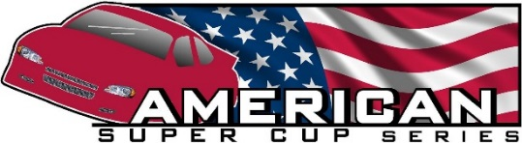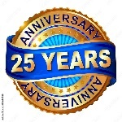

Dember 22, 2023 – Press Release

25 Season of Super Cup Racing will begin in April of 2024!!

American Super Cups Racing Series is proud to announce our 2024 Racing Schedule.

We would like to thank all the great Midwest Tracks for working with us to develop a schedule that will allow us to run our complete season with minimal back-to-back weekends and still give drivers a chance to participate in family, partners and personal activities throughout the summer. A special shout out to Grundy Speedway for allowing American Super Cups to return and help establish a Grundy Friday Night Super Cup Series. The rules and series will be run by Grundy under American rules and procedures. This will giver drivers the ability to run a Friday only series and/or Travel with American in the Midwest. We will be working closely to increase car counts for both series. Details coming after the first of the year!

This schedule will challenge drivers young and old, rookies and seasoned veterans. We race on flat tracks to high banked paved ovals. We race in front of large crowds on weekends that provide sponsors great exposure. Our touring racing series gets a maximum number of laps due to our reputation of ensuring great races for drivers, sponsors and fans. History has shown that we have consistently run the closest nose to tail, side by side racing of any Super Cup Series. Each night of racing is close and our year end point’s race always come down to a last night performance that will thrill all.

If you are interested in more information - check out our website at www.americansupercups.com or email us at mellis31@att.net.

Here is our tentative schedule and we hope to see you at the track this season.

February 23-25 World of Wheels–Milwaukee-Wisconsin State Fairgrounds
March 8-10 World of Wheels–Chicago-Rosemont Convention - 2 cars confirmed

April 6 (Sat) Practice? Information to follow
April 13 (Sat) Practice? Information to follow
April 20 (Sat) 1. Grundy County Speedway – Spring Classic Opener

May 11 (Sat) 2. Dells Raceway Park
May 27 (Mon) 3. Golden Sands - Memorial Day – Trickle 99

June 16 (Sun) 4. Slinger Speedway-Evening Race
June 22 (Sat) 5. Dells Raceway Park
June 28 (Fri) Back 2 Back 6. Tomah Speedway-4th of July-Thunder in the Valley-Big 8 Firecracker
June 29 (Sat)Back 2 Back 7. La Crosse Speedway – Full night of Racing

July 14 (Sun) 8. Slinger Speedway-evening race - Small Car Nationals
July 20 (Sat) 9. Dells Raceway Park – Monster Truck/Double Race Afternoon/Evening

September 2 (Mon) 10. Golden Sands-Labor Day with Tundra Series
September 8 (Sun) 11. Slinger Speedway-day race Championship Sunday

December - TBA 2024 – 25th Annual American Super Cup Racing Series Championship Banquet

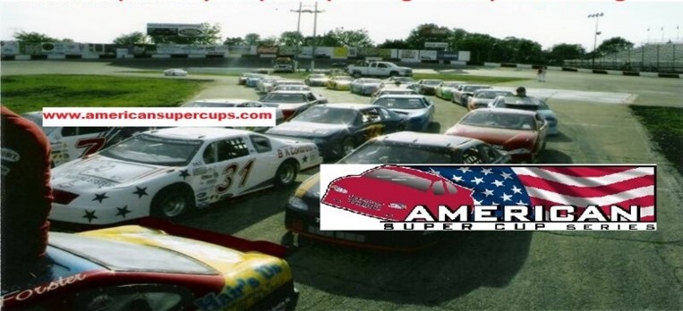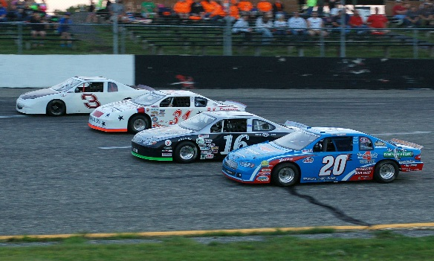

Spring must be here – The schedule says so!

Team 31 Racing and American Super Cups Racing Series is proud to announce our 2023 Racing Schedule.

Race Partners, fans, friends and family, 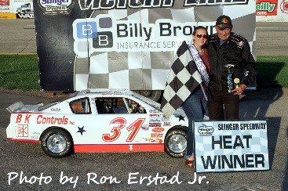 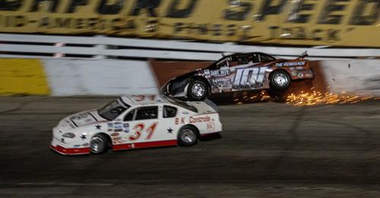 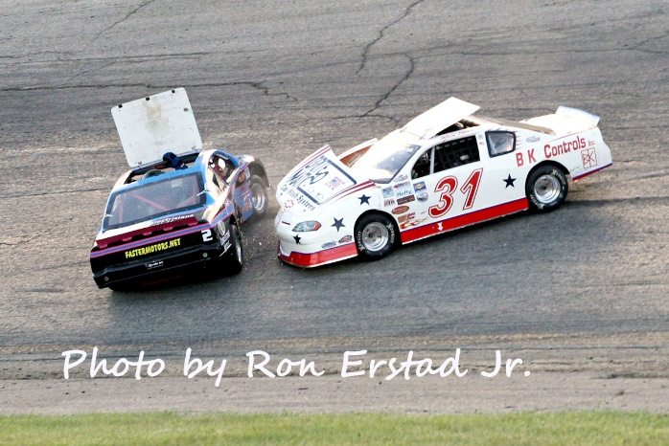 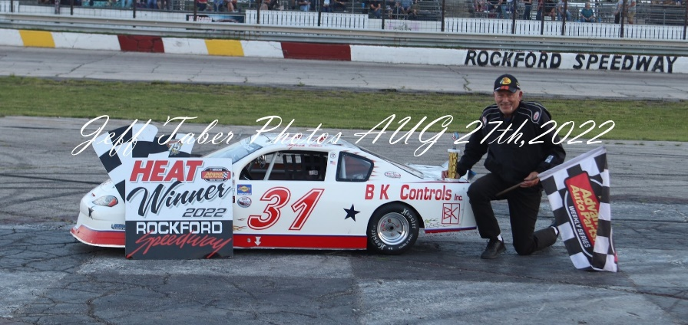

2022 was another great season of racing for the team. We were able to notch 4 wins over the summer and for the 1st half of the season we were in 2nd place. As the season moved on we encountered a few issues and slid in the standings to finish 4th overall. The top 5 drivers were separated by just a few points and put on great races throughout the summer. We have now achieved over 50 wins over the years – Very proud of that accomplishment and could not have doe it without your support.

2023 will be our 24th season of Super Cup racing and once again we are looking forward to an exciting season of door-to-door racing.

We would like to thank all our great partners that make racing possible. Brite-O Matic Mfg. and BK controls Inc. have always stepped up to help this team make the races throughout the season. With all the cost of racing going up since we first started racing their unwavering support is greatly appreciated. We could not race this series without your support. Also, a huge shout out to Ultimate Motorsports for keeping the Team 31 Racing car in tune and competitive every week.

We just were at Chicago world of wheels in Rosemont convention center to support the series and partners. Makes your heart ache for spring seeing all the cars of summer. It will be here soon,

As for racing the schedule is below and we getting ready for sad to say Rockford Speedways last season. The announcement was just made in February and will be a great loss for the area. The area around the track keeps getting built up and the property is worth too much and the owners have decided to sell. We still have a nice schedule just over the border in Wisconsin and will be looking into alternatives for next season. So make sure to attend one of our races this summer and enjoy some short track racing in your backyard.

History has shown that we have consistently run the closest nose to tail, side by side racing of any Super Cup Series. Each night of racing is close and our year end point’s race always come down to a last night performance that will thrill all.

Here is our schedule and we hope to see you at the track this season.

If you are interested in more information - check out our website at www.americansupercups.com or email us at mellis31@att.net. Or call/text 312-350-5566

March 3-5 World of Wheels–Chicago-Rosemont Convention Center

April 23 (Sun) 1. Slinger-Day race-24th Annual Season Opener

May 13 (Sat) 2. Dells Raceway Park-Full night of Racing-Pro Lates, Mods, Bandits & Sixers
May 20 (Sat) 3. Rockford Speedway
May 29 (Mon) 4. Golden Sands - Memorial Day – Trickle 99

June 24 (Sat) 5. La Crosse Speedway – Full night of Racing
June 30 (Fri) 6. Tomah Speedway-4th of July-Thunder in the Valley-Big 8 Firecracker

July 15 (Sat) 7. Dells Raceway Park-Full Night of Racing-Super Lates, 602’s, Sportsman, Legends
July 16 (Sun) 8. Slinger Speedway-evening race - Small Car Nationals
July 29 (Sat) 9. Rockford Speedway

August 26 (Sat) 10. Rockford Speedway

September 4 (Mon) 11. Golden Sands-Labor Day-Tundra Series
September 10 (Sun) 12. Slinger Speedway-day race-Kinetic Motorsports Championship Sunday

